Example Family TA Fidelity Checklist
This checklist was developed by the National Center on Deaf-Blindness for state deaf-blind projects to use as part of family technical assistance. Replace with your own logo and disclaimer and adapt as needed for your project.

# | Fidelity Question | Yes/No | If not, what needs to be done?
1 | Are we adhering to our project’s selected universal, targeted, and intensive TA activities for families?
2 | Are we using our intake process with all new families?
3 | Are we meeting our deadlines for targeted TA?
4 | Are we meeting the action plan deadlines for intensive TA?
5 | Are we supporting the number of families we said we would serve for targeted and intensive TA?
6 | Are we adhering to the defined amount of time outlined for supporting individual families in their action plans?
7 | Have we successfully partnered with other agencies and organizations to serve families?
8 | Are we supporting families from across the state or is there too much of a concentration in one region?
9 | Have we made strides toward supporting families from a variety of cultures?
10 | Are we being realistic about our project’s capacity?
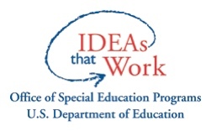
The contents of this document were developed under a grant from the U.S. Department of Education, #H326T180026. However, those contents do not necessarily represent the policy of the U.S. Department of Education, and you should not assume endorsement by the Federal Government. Project Officer, Susan Weigert.

